Lincoln County Animal Services
Advisory Board Meeting Minutes
200 Gamble Dr.
Lincolnton, NC 28092
February 4, 2025
6:00 PM

Attendees:
Dr. Ashley Oliphant, Chairman to the Board
Stefanie Westmoreland
Dr. Stephanie Bowling
Lena Jones
Tim Grass
Dawn Tutterow
Michael Allred, Sr.
Jana Aviles, Animal Services Director
Chelsea Cooper, Animal Services Operations Manager
Lindsey Houser, Clerk to the Board

Members of the Public:
None

Opening:
After the board received their meeting materials, Chairman Oliphant opened the meeting at 6:03 PM.

Adoption of the Agenda:
A motion was made by Chairman Oliphant to amend the proposed agenda, adding the election of a Vice Chairman to the Animal Services Advisory Board. The Board was in favor, and chose to adopt the amended meeting agenda, with none opposed.

Adoption of Minutes:
A motion was made by Stefanie Westmoreland to adopt the minutes from the previous Animal Services Advisory Board meeting dated December 3, 2024. A second was made by Michael Allred, Sr.

Election of Vice-Chairman:
Dawn Tutterow volunteered to serve as Vice Chairman to the Animal Services Advisory Board. Chairman Oliphant made a motion to elect Dawn Tutterow as Vice Chairman to the Animal Services Advisory Board. The Board was in favor, with none opposed.

Next Meeting Dates:
- Tuesday, May 6th, 2025, at 6:00 pm
- Tuesday, August 5th, 2025, at 6:00 pm
- Tuesday, December 2nd, 2025, at 6:00 pm

Animal Services Report:
Director Jana Aviles gave the following report to the Board.
- Staffing
  - Conducting Interviews for Animal Services Officer
  - Full time Registered Veterinary Technician begins on February 10th.
  - Darra (Surgery Assistant) is still on leave

- 2024 Statistics
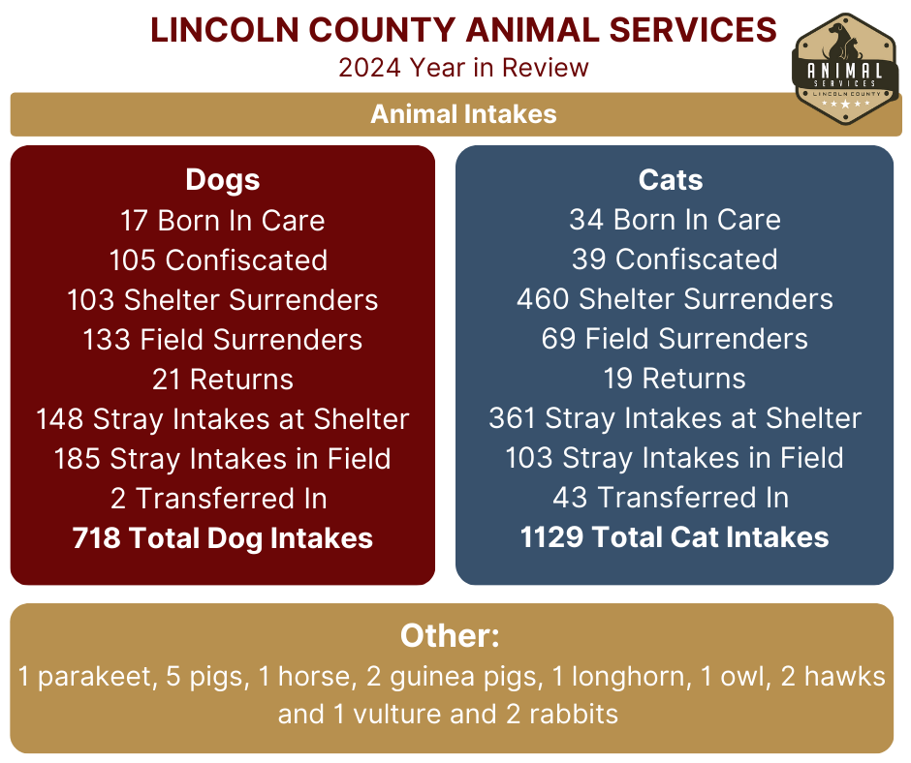

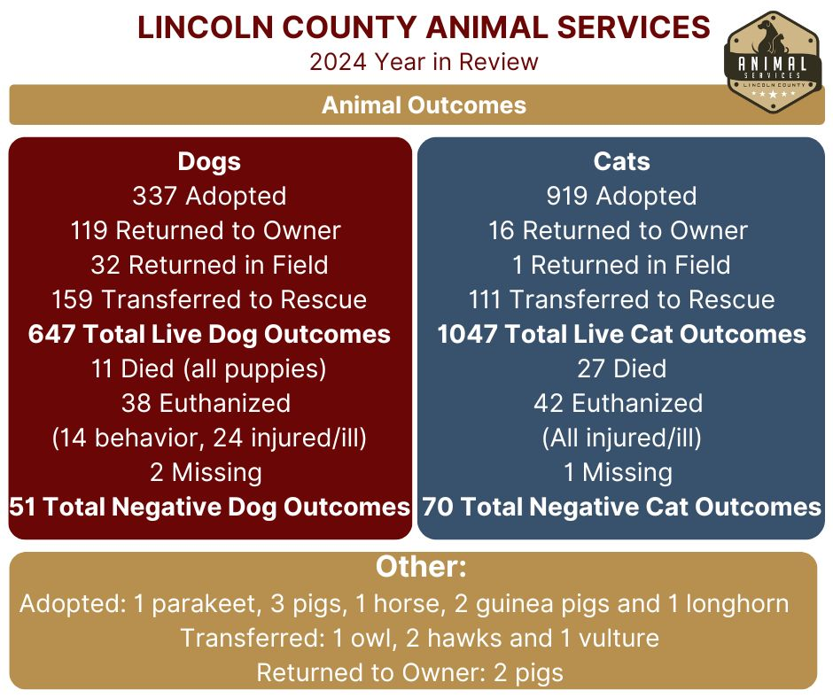
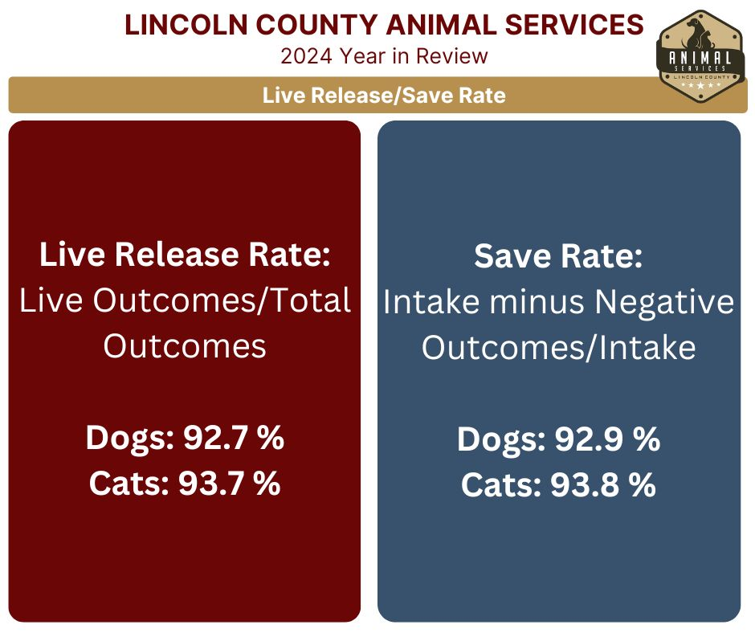

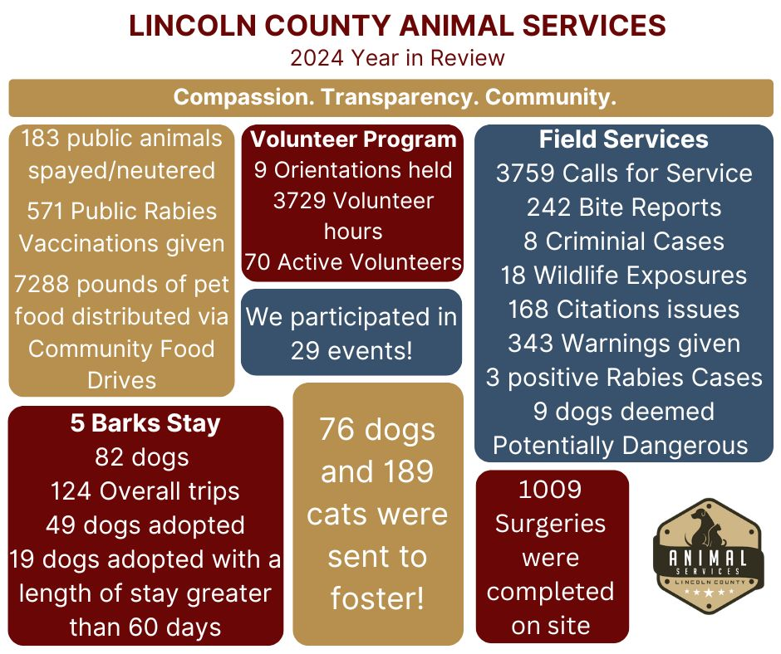
- Applying for Clinic License
- Website Updates
- Upcoming Events:
  - Valentine’s Day Reduced Fee Adoptions and 5 Bark Stay Promo- Feb. 14
  - New Volunteer Orientation- Wednesday, February 19th at 5:15 pm.
  - Community Service Donation Day- Battleground Elementary (K5)- Friday, February 21- time TBD
  - Donation Drive- Presentation- Battleground Elementary (5th grade) February- date and time TBD
  - Pack the Pallet- Friday, March 7 at Walmart, 11 am to 3 pm.
  - Adoption Event- Saturday, March 15- Untapped Territory- 1 to 6 pm
- Upcoming Staff Training:
  - Carolina’s Unite (Jana) – Leading Presentation on Hurricane Helene
  - HSUS Expo (Jana) – Received Full Scholarship
  - Dogs Playing for Life – Received Full Sponsorship
  - Working on hosting a Veterinary Forensics Course with HSUS
- Ordinance Updates:
  - Currently going through legal
  - Exotic Owner Registration fees currently on hold
  - Addition of Do Not Adopt Criteria
    - Anyone that has been charged with animal cruelty and/or is currently under investigation for animal cruelty, animal neglect or chronic nuisance complaints.
- Pet food pantry changes to make it more accessible for the public
- Director Aviles and the Community Support Team gave a presentation at the Rotary Club meeting on 2/3/25.

In response to Director Aviles’ report, Chairman Oliphant advised that she had recently met with LCAS management, County Manager Davin Madden, and members of HATS, in which she voiced her support of LCAS and her satisfaction with the shelter’s data reporting and trajectory.

Community Support Program- Manager Cooper
Operations Manager Cooper gave the following report to the board:
- Two members of the Community Support Team, using their positions to assess the need for resources and support throughout the Lincoln County community
- January 2025:
  - 28 Found Animal Reports received
  - 19 Lost Animal Reports received
  - 45 Owner Surrender Requests received
    - Some reports dealt with more than one animal
- Community Support Team encouraging responsible rehoming outside of shelter
  - 7 dogs placed with rescue outside of shelter
- Monthly TNR transport for 10 feral cats with NC Snip- working with HATS for placement of ferals
- January transport had 8 cats, resolving one property’s feral cat repopulation issue
- Working on standardizing verbiage for common topics across the shelter
- Low Cost Voucher Program
  - Reworking current Low Cost Spay and Neuter program- moving away from LCAS working a monthly transport, moving towards partnership with NC Snip for a voucher system, public fee paid to LCAS for voucher, making surgery scheduling and transportation to/from on owner
  - Proposed increase on fee schedule, would be effective July 2025
In response to Manager Cooper’s report, Dawn Tutterow asked for clarification on the Low Cost Voucher Program, and if there would be tracking to ensure that voucher’s are being utilized by the public. Manager Cooper advised that there will be a Share Drive used by both LCAS and NC Snip to track vouchers.

Discuss Ordinance Updates- Director Aviles
Director Aviles advised that in the updated ordinance, if a containment order is violated, ownership of said animal may be terminated, and that appeals to ownership termination would need to be heard. Director Aviles asked if the Animal Services Advisory Board would be willing to hear these appeals.
Chairman Oliphant asked what this process would look like. Director Aviles advised that situations that could be addressed with a containment order happen almost daily, so these appeals would likely occur frequently. Director Aviles recommended these cases be reviewed by email, rather than in-person. Chairman Oliphant advised that she would be opposed to the hearings bleeding into Animal Services Advisory Board meetings, but she was open to reviewing and voting by email. Chairman Oliphant also suggested talking with the Board of Commissioners about the creation of a working group to handle appeals.
Stefanie Westmoreland asked for clarification on the legality of terminating ownership rights to an animal. Director Aviles responded, advising that the ordinance would give the legal authority to do so.
Michael Allred, Sr. asked if there was an approximate date that the ordinance would be presented to the Board of Commissioners. Director Aviles advised that it is currently with legal for review. Allred, Sr. advised that he had attended a Dangerous Dog Board hearing last week, where he along with other board members expressed concern about the muzzle requirement for the dog that had been deemed potentially dangerous. Director Aviles advised that the Director could add to requirements established in the current ordinance but could not take away from these. Allred, Sr. asked if the Dangerous Dog Board could go into closed session. Director Aviles added that the ordinance allows 10 days for a decision from the Dangerous Dog Board. Chairman Oliphant stated that closed session in these hearings may give a bad look, but she would be open to deliberating with the board via email. Lena Jones asked if these hearings would be subject to open meeting law. Director Aviles advised that she would follow up with legal on this.
Dawn Tutterow gave kudos to Lincoln County Animal Services officers on their recent court appearances with criminal cruelty cases.

Public Comments:
None

Motion to Adjourn:
A motion was made by Michael Allred, Sr., with a second by Dawn Tutterow.
The meeting ended at 6:44 PM.

